**Reports of Activities**

**Class-|||**

**Month-December**

**Session-2021-22**

**National Pollution Control Day**

**December 2, 2021**

**Written by: Ms. Twinkle Sahdev**

National Pollution Control Day focuses on preventing pollution and raising awareness about the ways we keep exploiting Mother Nature. This day is observed on Dec .2, every year in remembrance of the people who passed away in the Bhopal Gas Tragedy, 1984.

**Activity on National Pollution Control Day**

The students were guided by the teacher to create a scene on an A4 sheet to show different kinds of pollution like - Air Pollution, Water Pollution and Land Pollution.

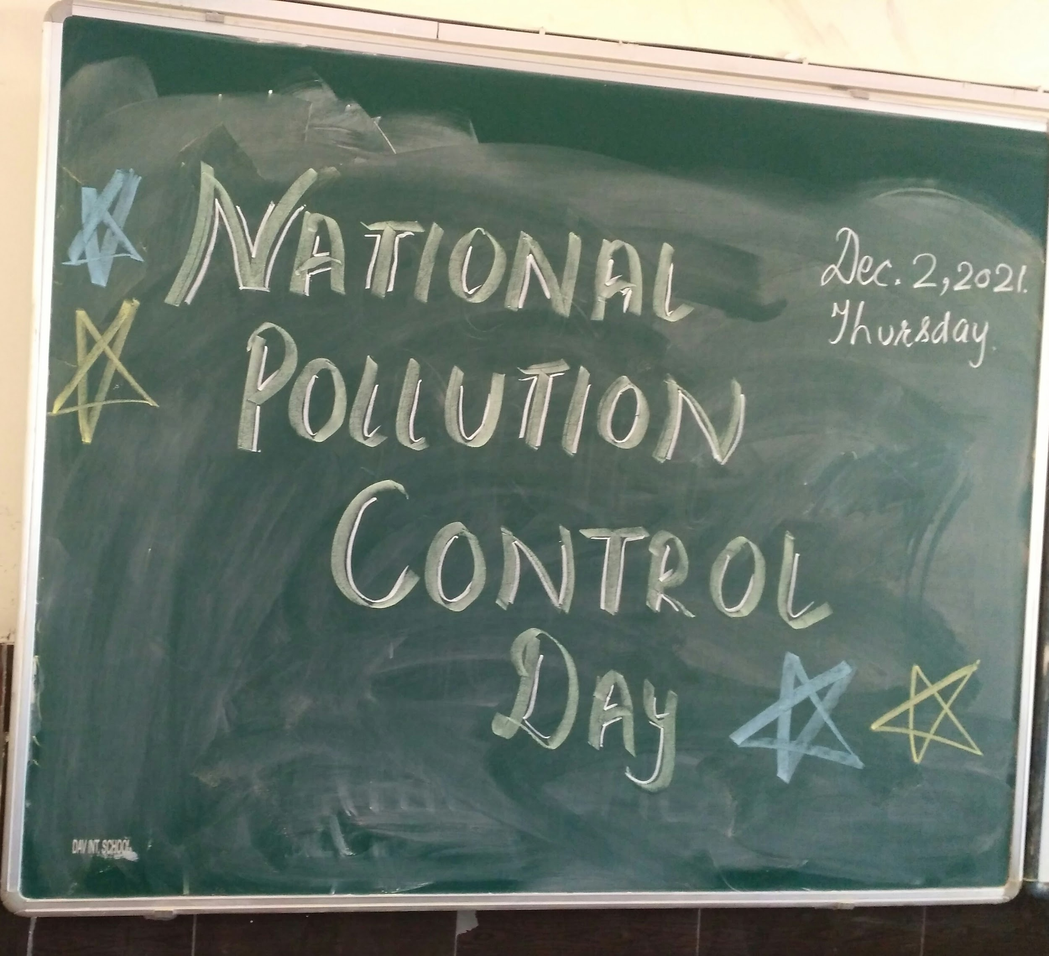

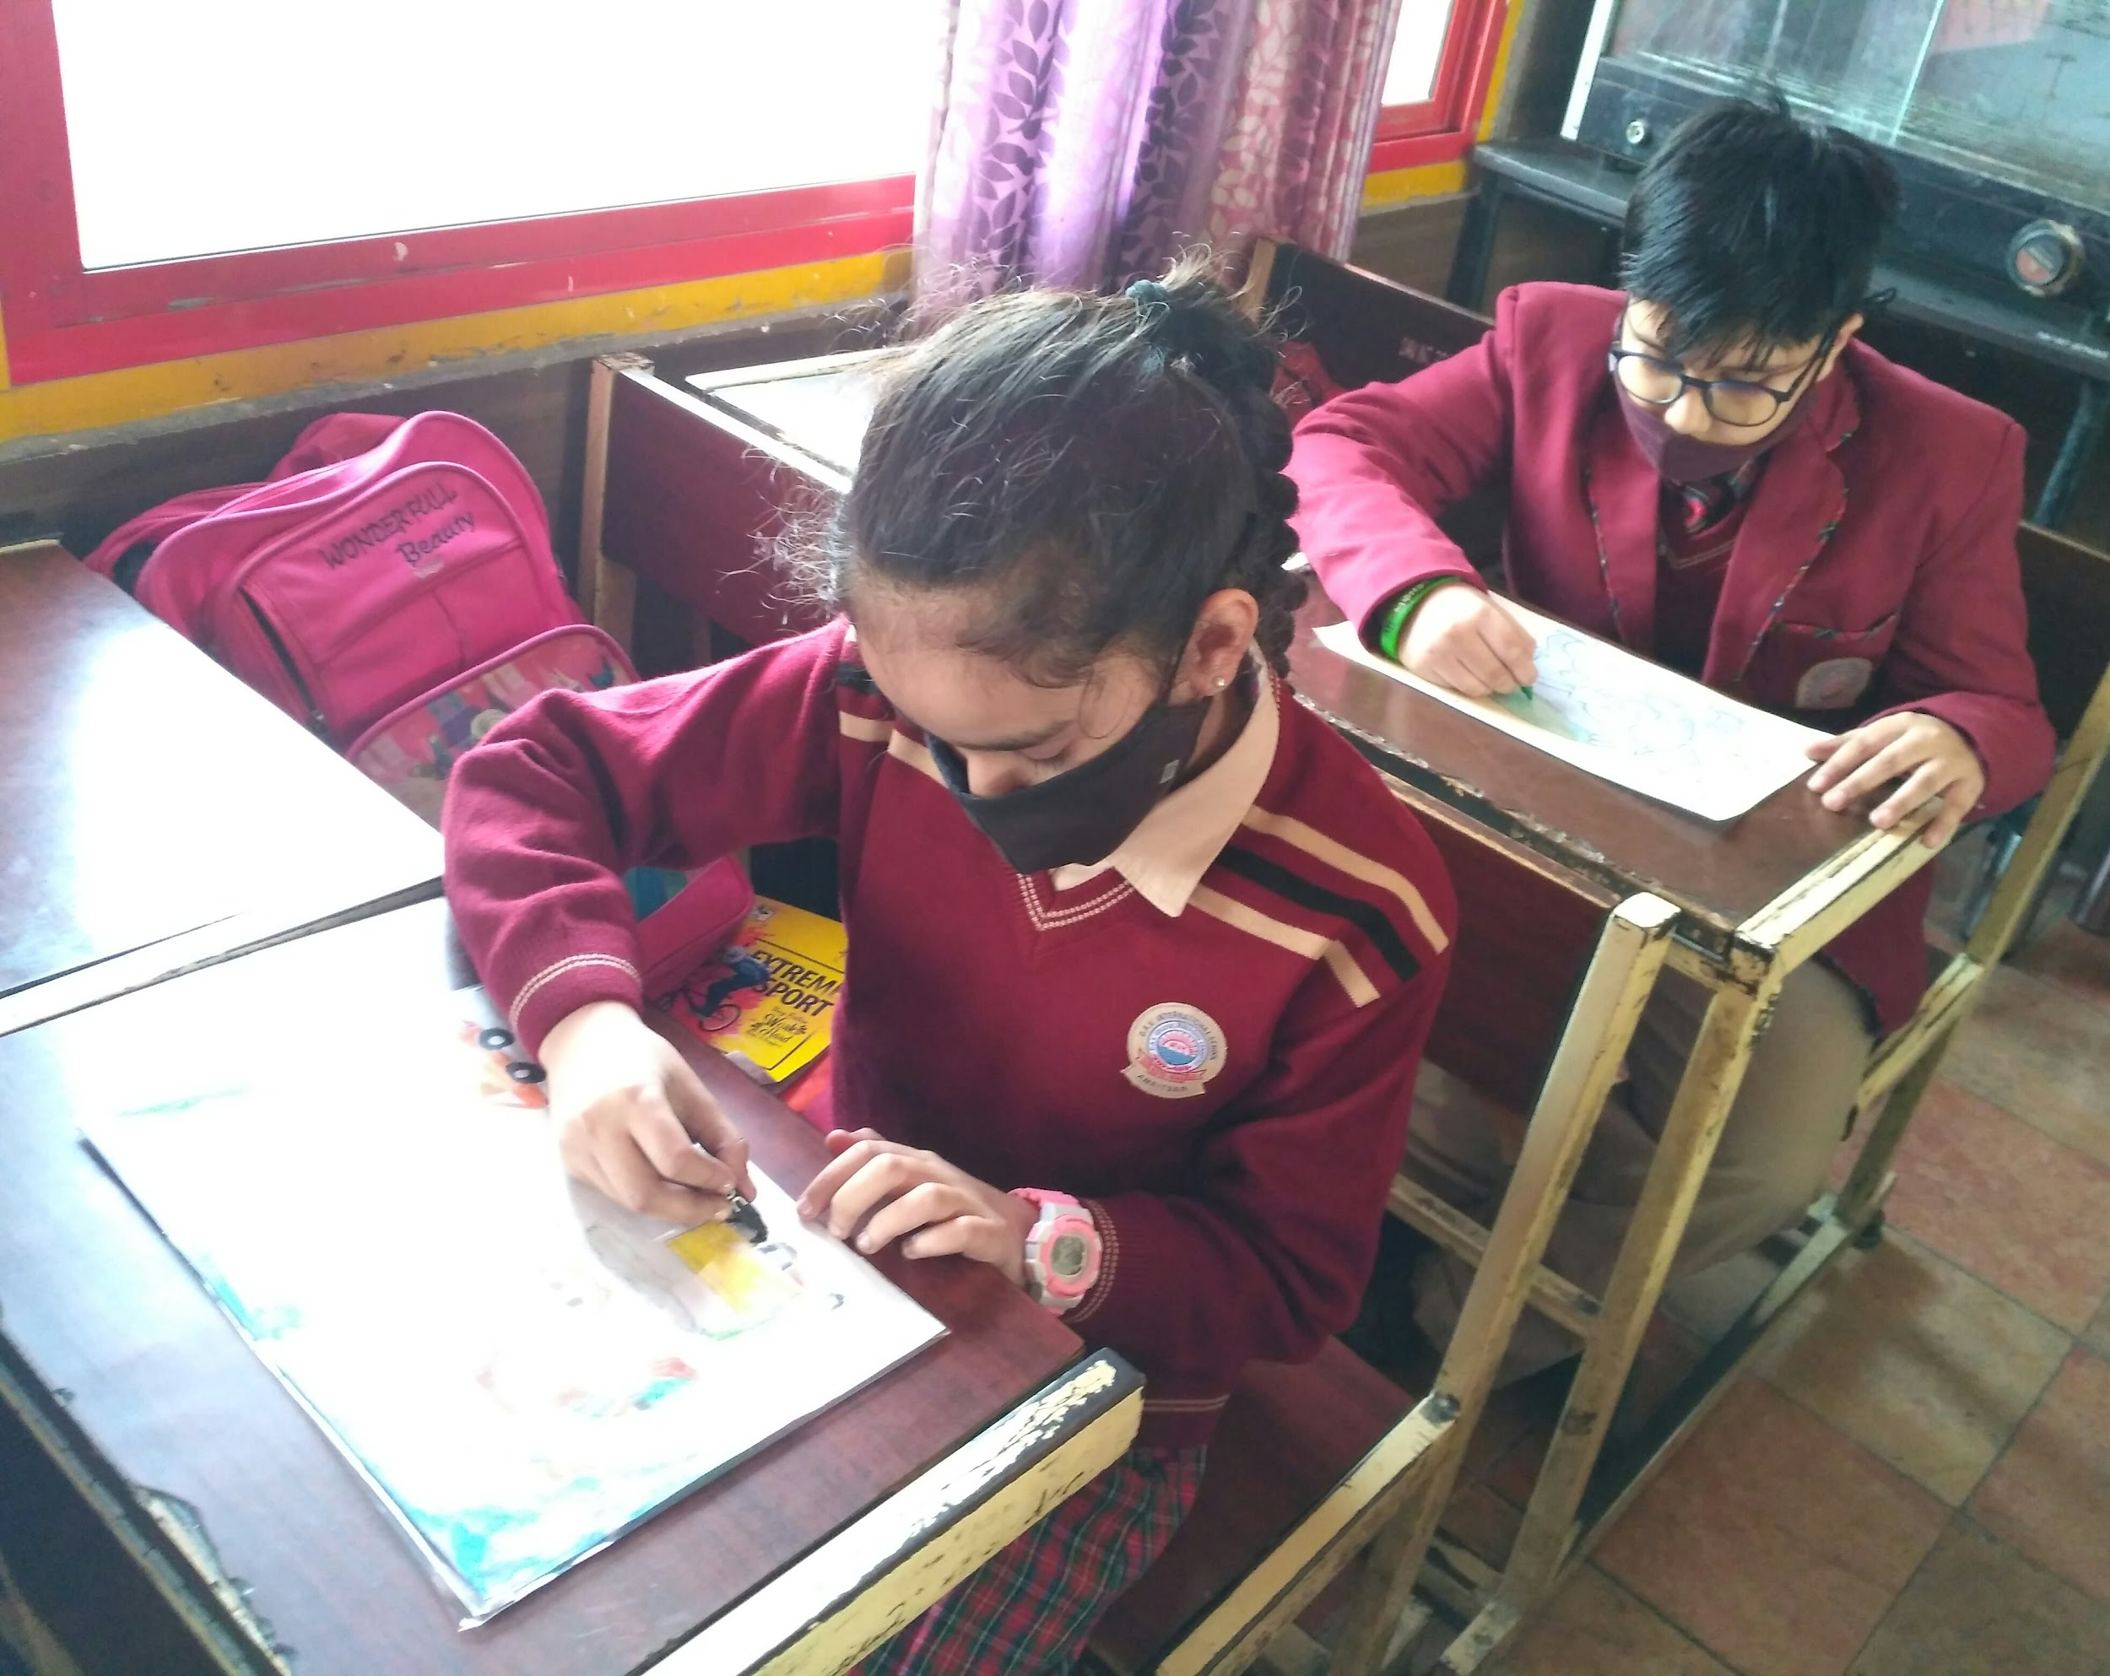

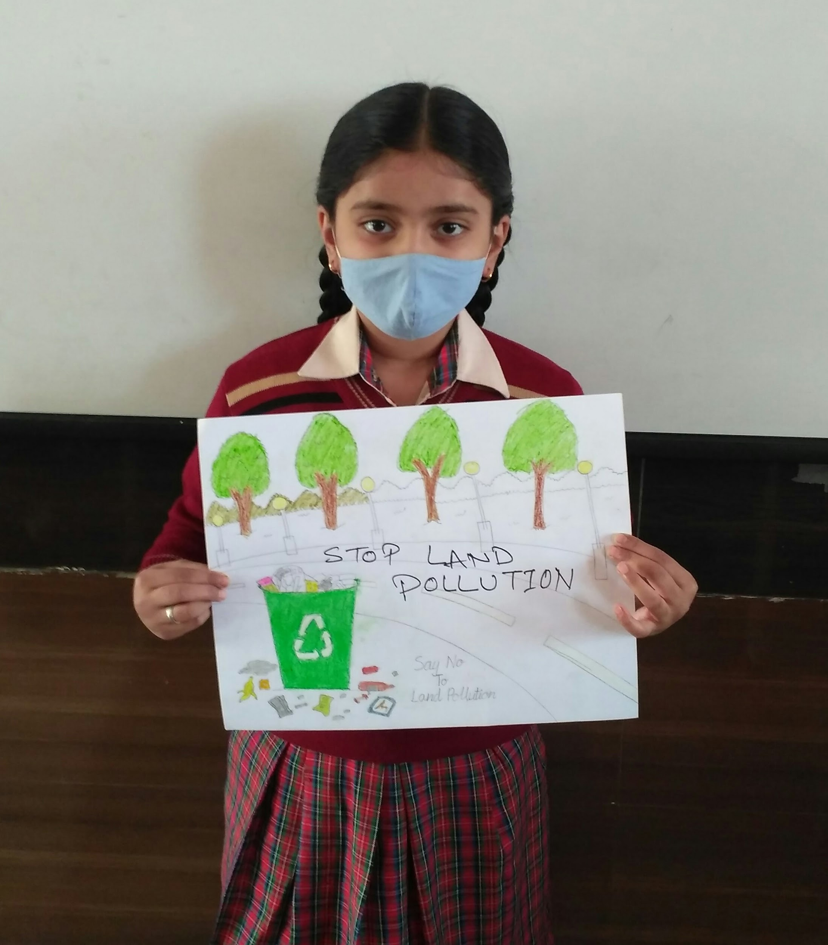

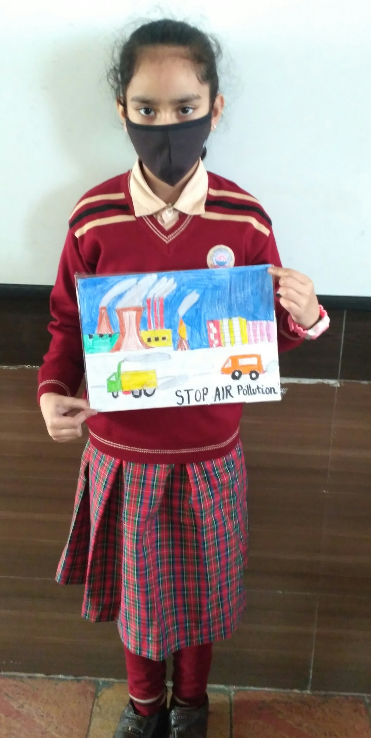

**Armed Forces**

**December 7, 2021**

**Written By: Ms. Mauli Arora**

The Armed Forces Flag Day or the Flag Day of India is a day dedicated to India towards collection of funds from people of India for the welfare of the Indian Armed Forces personnel. It has been observed annually in India on December 7 since 1949.

**Activity on Armed Forces**

Marathan was organized on Armed forces flag day.

**Human rights**

**December 10, 2021**

**Written By: Ms. Mauli Arora**

Human Rights Day is observed every year on 10 December – the day on which the United Nations General Assembly adopted, in 1948, the Universal Declaration of Human Rights. ... We can take action in our own daily lives, to uphold the rights that protect us all and thereby promote the kinship of all human beings

**Activity on Human rights**

Declamation was conducted on Human Rights Day

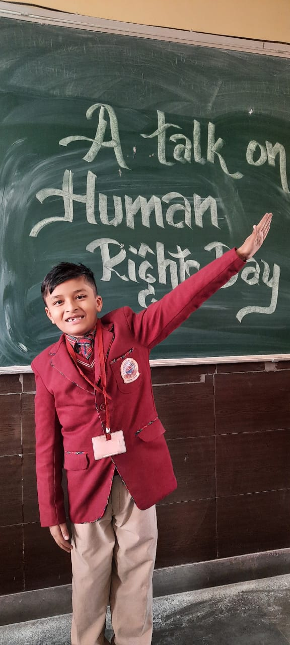 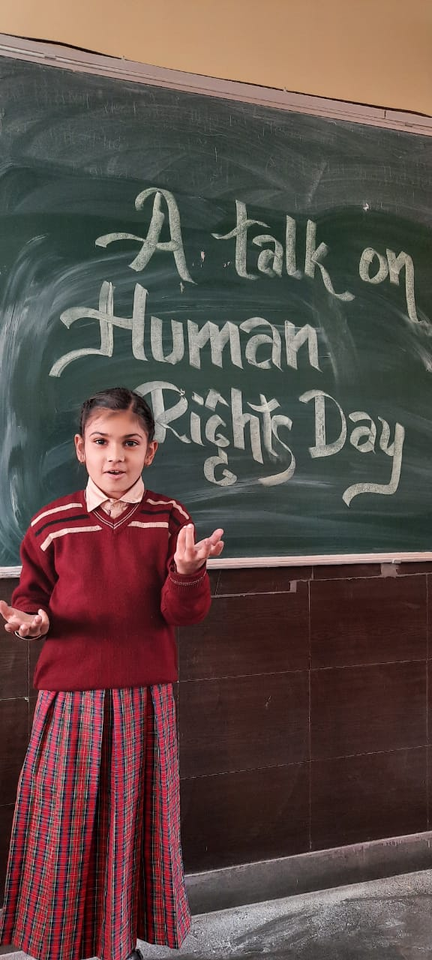 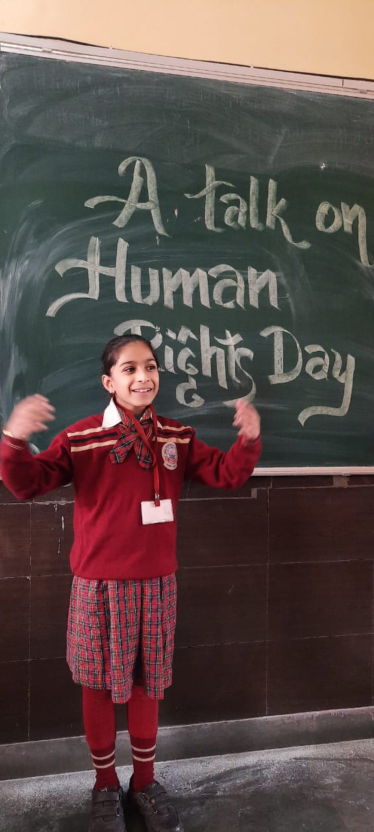

**National Mathematics**

**December 22, 2021**

**Written By: Ms. Mauli Arora**

India celebrates National Mathematics Day on December 22 every year. The day marks the birth anniversary of famous mathematician Srinivasa Ramanujan. In 2012, then Prime Minister Manmohan Singh Declared the date as National Mathematics Day to honor the great man.

**Activity on National Mathematics**

* Students were encouraged to learn a poem on "Math’s is a Fun".
* Teacher composed a Jingle of healthy habits using symbols of addition, subtraction, multiplication and division. Students were encouraged to learn that Jingle thoroughly and follow rules regularly.
* A trick of table of 9 was told to students. Students enjoyed the trick very much.

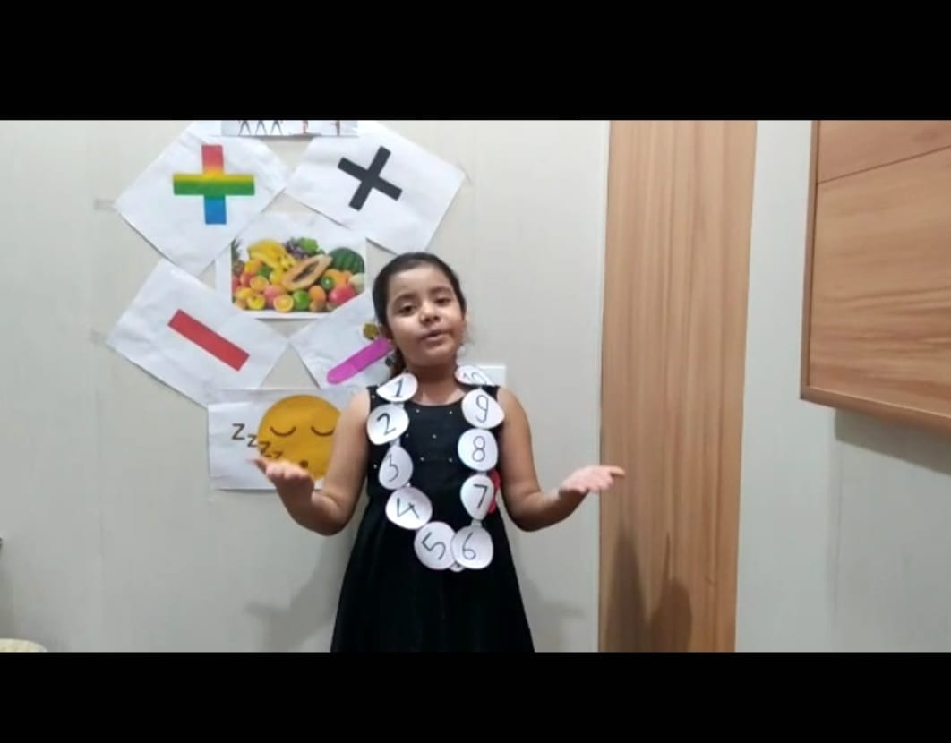

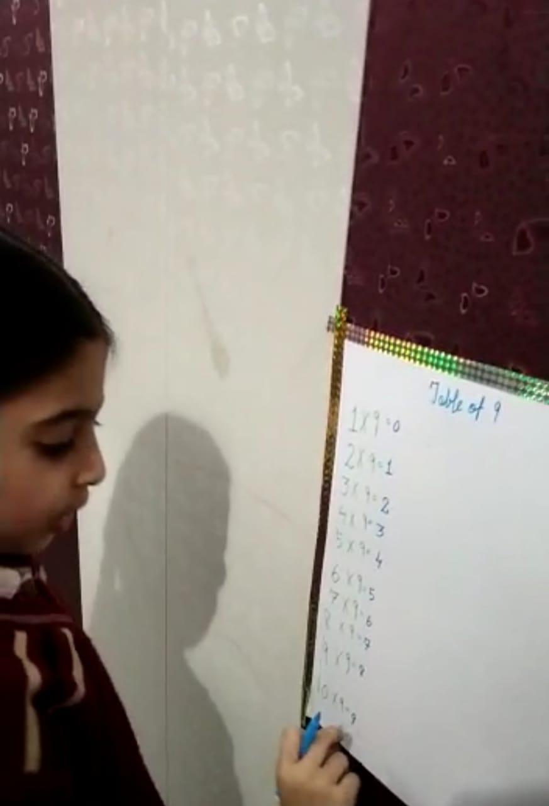 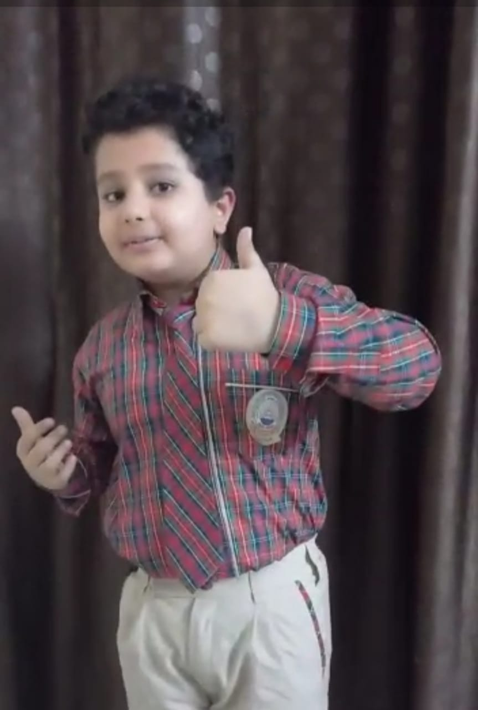

**Christmas**

**December 25, 2021**

**Written By: Ms. Mauli Arora**

Christmas Day is an annual Christian festival commemorating the birth of Jesus Christ, the Son of God. Specifically, the meaning of Christmas comes in the remembrance and celebration of God's presence in our world through Jesus.

**Activity on Christmas**

Students were guided to do creative writing on Christmas

